  Hello, I am here to care for you!  My name is : ___________________ | I am :  - A Nurse  - A caregiver  - An intern  - ___________________

How are you feeling today?
- Are you experiencing pain?  o yes o No  Kind of pain:  - Stabbing pain  - Nagging pain  - Pulsing pain  On a scale of 1 to 10 ?  _______  - Are you feeling dizzy / nauseous ?  o yes o No | Where?  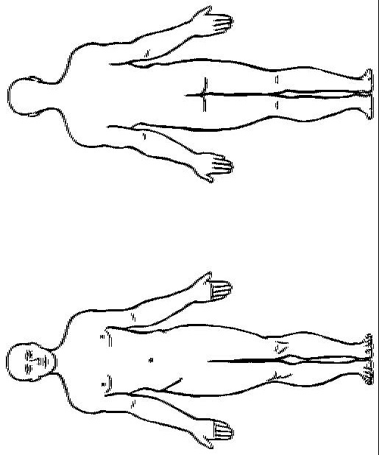

What am I here for at this time?
I’ve come to take a measurement:  - Your blood pressure  - Your saturation (oxygen level)  - Your pulse  - Your temperature  - Your glycemia (sugar)  - ___________________ | - to bathe you  - to clean your wounds  - to take blood sample  - ___________________

What will happen today? Do you have any questions for me?
- Today you have  - A consultation  - An operation  - ___________________  - You need to stay sober from ____ h.  - You can’t have anything to eat/drink, starting now  - You have to wear a hospital gown  - Please remove all jewelry/glasses/lenses/prostethics  - Please remove / keep on your underwear | - Medication? diagnosis?  - Wound care?  - Another caregiver?  (physiotherapist, doctor, …. )  - Family members?  - ___________________

Notes

